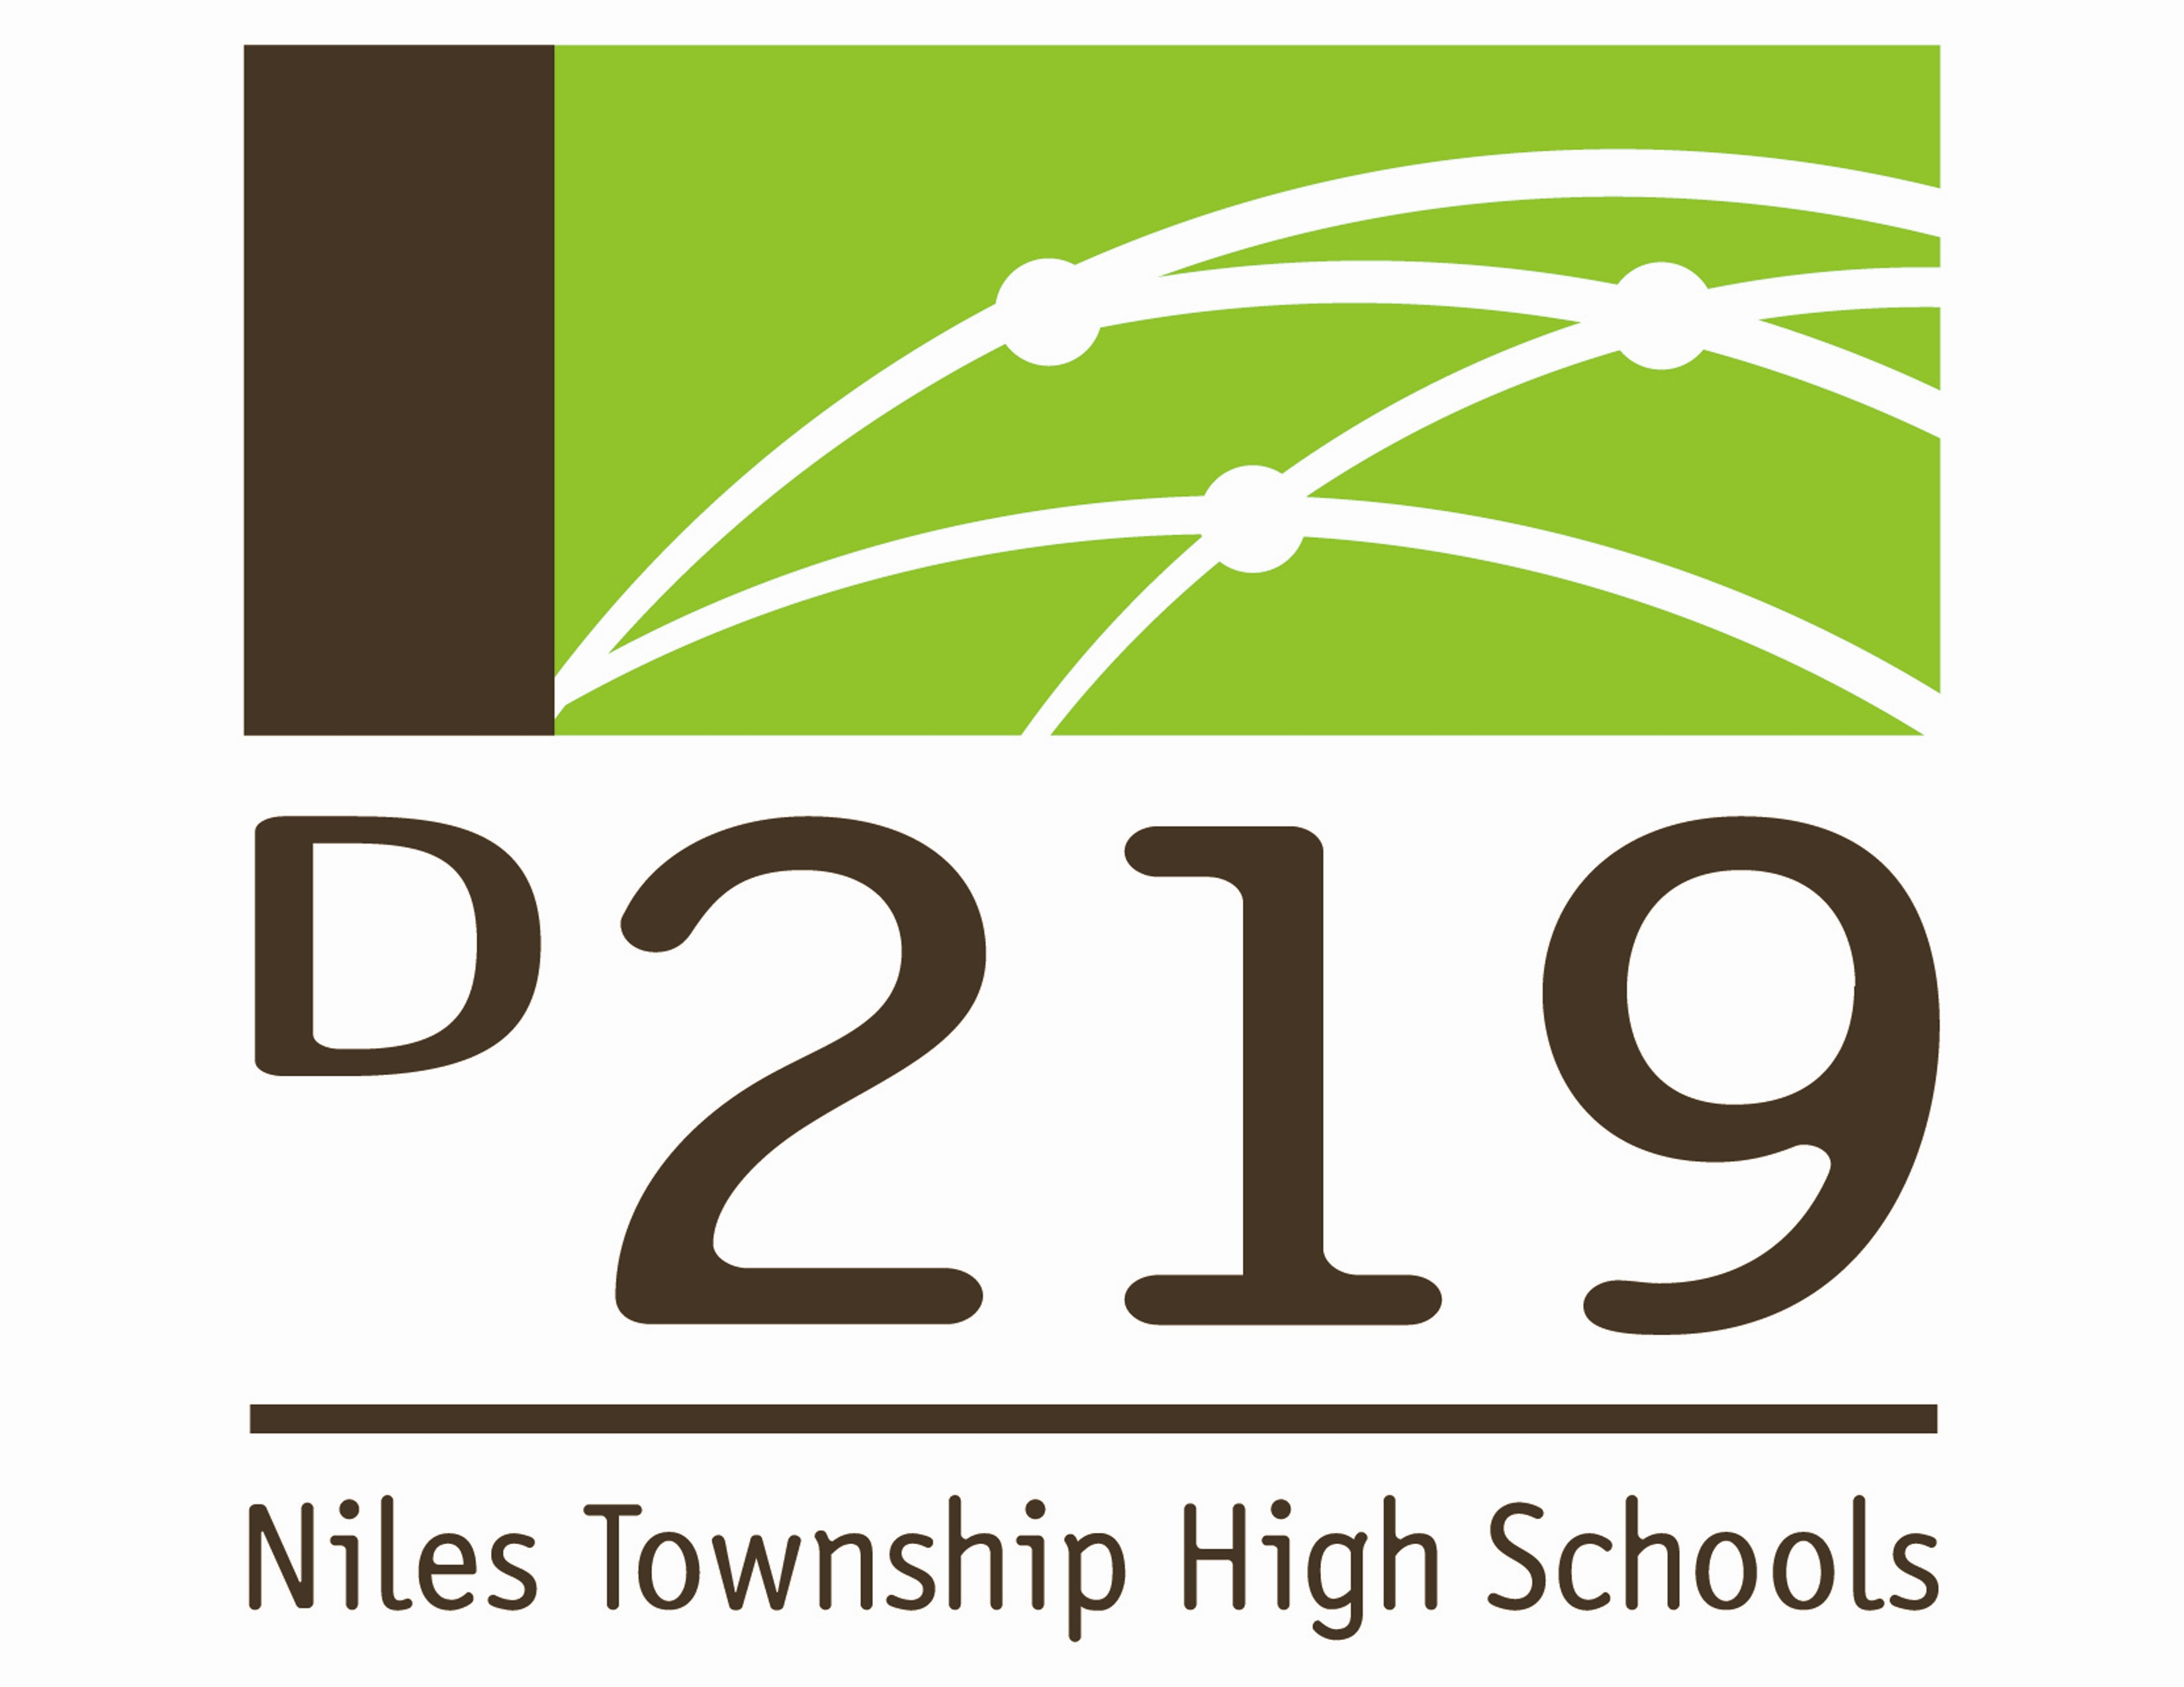
August 7, 2015

NOTICE OF SPECIAL
BOARD OF EDUCATION MEETING

The Board of Education of Niles Township High School District 219 will conduct a special meeting on Monday, August 10, 2015 at 6:00 p.m. in the Board Room, at the Administration Center, located at 7700 Gross Point Road, Skokie.

The purpose of the meeting will be appointment of legal counsel and personnel.

DATE: Monday, August 10, 2015
TIME: 6:00 p.m. Closed Session
6:15 p.m. Open Session
6:30 p.m. Closed Session

LOCATION: Board Room
District 219 Administration Center
7700 Gross Point Road
Skokie

